Saving Seeds and Seed Raising

Why?
Very satisfying, cheap, can select varieties that suit your soil and climate preserve heirloom varieties.
Commercial seed are often hybrids, suited for cropping all at once and good travelling. They produce identical plants which mean all succumb to insects or disease if attacked; seeds can be infertile or will revert to original parent plants.

Seed collecting

From good seed suppliers (list at the end of these notes), local gardeners, local seed saving groups (find on the map at http://seedsavers.net/shop/home/local-seed-networks/)

Collecting your own - allow seeds to fully ripen on the plant (e.g. pea and bean pods should be dry on the bush or vine before collecting), fruit to be very ripe before picking ( e.g. tomatoes soft and without insect attack - pull out pulp and wash in water to remove some of the gel from around the seed, then dry on a paper towel).

NB Cross- pollination - some seeds will be produced from two varieties of the same family. This is undesirable as the resultant plants may not have desirable traits. The cucurbit family are the worst offenders - cucumber, watermelon, rockmelon, pumpkin, squash and zucchini. So only plant one variety of pumpkin, one variety of cucumber, etc if you plan to collect the seed from them.

Storing Seeds - dry, cool place in glass, paper or plastic containers and silica packets in with the seeds to absorb any moisture. Well labelled with variety, date collected and where collected.

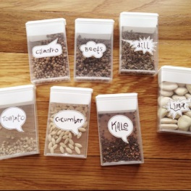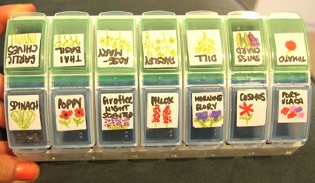

Easiest seeds to start saving for beginners: Basil, beans, broad beans, coriander, fennel, garlic, garlic chives, lettuce, marigold, nasturtium, pea, sage, snake bean, tomato.

Propagating Seeds

Potting/seed raising mix
Sieve mature compost to make a seed raising mix OR cheap potting mix plus coir peat (1:1) plus sifted compost or worm castings. Only add fertilizer after the seeds have germinated as seeds only need the correct soil temperature and water to start germinating so be careful about getting unused seeds wet.

Potting trays and pots - recycle milk containers, yoghurt containers, egg cartons, toilet or paper rolls and polystyrene boxes. The ideas are endless. Any plastic pots can be sterilised with water and vinegar and then put out in the sun to solarise or use 1 part bleach to 9 parts water for 10 minutes then wash and dry.

Germinating seeds The general rule is:

Large seeds - directly in to the soil ( eg peas, beans, corn, cucumber, pumpkin, zucchini)
Small seeds - in to seed raising mix, transplant when more than two pairs of leaves (eg lettuce, broccoli, cabbage, cauliflower, etc)

Tips 1. Very small seed can be mixed with sand to make it easier to spread the seed.
2. Some small seed vegetables do not like being transplanted so sow directly into the soil too -
carrots, beetroot, radish, parsnip, etc. OR plant into a biodegradable pot

Soil temperature must be about right - be seasonal and follow a local planting guide. Air temperature is of secondary importance. The majority of vegetable seeds take a week to germinate but some take a long time, so be patient (eg broccoli 7-10 days, onion 10-20 days carrots 14 -21 days, celery 20-20 days).

Depth to plant seeds- 2 to 3 times the size of the seed. (3 – spring/summer and 2- autumn/winter).

Watering 1.Check daily and water lightly so the seeds aren't disturbed or exposed to sunlight (except for lettuce). Use a cool drink bottle and squeeze gently.
2. Don't over water - keep soil damp not wet.
3. Once the seeds have germinated you can water with a weak seaweed solution to help them along - creates thicker more resilient cell walls and stronger root systems.

TIPS Some seeds like to be soaked before hand - beetroot, silverbeet, peas.
Never use up all your seed. The others you just planted may not germinate.

Label seedlings/ seeds with milk carton cut outs and a permanent ink pen (water and sun can destroy most labels) - date, variety and source where collected (eg 6th April 2016, Sprouting broccoli, Diggers)

Other Propagation techniques
1. Cuttings - tip cuttings - rosemary, oregano, marjoram, sage, tarragon, thyme,
2. Layering - strawberries, other cane berries, pumpkin, sweet potato, NZ spinach
3. Division - lemon grass, chives, rhubarb, asparagus, garlic chives, j. Artichoke, sorrel

Transplanting

Once the seedlings have two sets of leaves then you can transplant if required. Before doing this give the plants a little time to become accustomed to their new position before transplanting. This is called hardening off. Water in with a weak seaweed solution and or warm leachate (dissolved worm castings).

Where to buy Seeds
On-line open pollinated, non-hybrid, heirloom varieties from:
Permaculture farm near Geraldton http://yilgarnseeds.drylands.org.au/order_seeds/order_seeds.html
Very reliable seeds and big variety http://www.diggers.com.au/ (NB Vict. company)
Local company http://www.daisychaineconursery.com/index.html
Organic seeds:
https://greenharvest.com.au/SeedOrganic/OrganicSeedIndex.html (NB QLD company)
https://www.edenseeds.com.au/About-us (NB QLD company)
Well established seed range (many hybrid varieties): Yates
http://www.yates.com.au/products/seeds#OeGL8IA7lR21flXA.97
References
The Seed Savers' Handbook, Michel and Jude Fanton
Vegetable Growing: A guide for home gardeners in Western Australia

